Goonhavern Primary School- Design Technology
TOPIC: DT | YEAR: 5 | STRAND: Textiles

What should I know already? | What will I know by the end of the unit?
- A sock puppet is made out of sock and can be used using your hand  - There are different types of materials  - Scissors need to be used carefully especially in a busy classroom  - Some materials are harder to cut  - I can use a template to help me with my design  - I know how to create a simple stitch using a needle and thread  - How to create a running stitch  - How to use a pattern for my design | Design  - A design needs to be backed up by research and fit for its purpose  - I can choose a design based on its ability to meet its purpose:  - I can explain Who will use it? Why? How? When?  - An inspired design is when your design is influenced by the work of someone else however not copied.  - A pattern is the template from which the parts of a garment are traced onto fabric before being cut out and assembled.  - Patterns are usually made of paper, and are sometimes made of sturdier materials like paperboard or cardboard if they need to be more robust to withstand repeated use.  Make  - Scissors can be used to cut fabric and sharper scissors may be needed for thicker/more rigid materials  - A pattern needs to be used during the making stage to ensure both mittens are the same size and shape.  - Stitching will need to be done on the inside of my design  Evaluate  - I followed my design criteria and where I didn’t I can explain my change and choices  Technical knowledge  - Sewing is stitching cloth, leather, furs, or other materials, using a needle and thread.  - Sewing can be done on a sewing machine, or by hand.  - "Plain" sewing is mostly done to make or mend clothing and household furnishings such as curtains, sheets, upholstery, and table linens.  - Backstitch - sturdy hand stitch for seams and decoration.  - Running stitch is a simple needlework stitch consisting of a line of small even stitches which run back and forth through the cloth without overlapping.
School Values
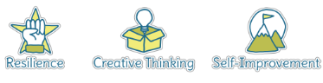
Five Ways to Wellbeing
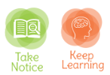

Vocabulary
Fabric | A cloth material
Felt | A thick and soft fabric
Rigid | Does not easily move/mould/cut
Design | a plan or drawing produced to show the look and function or workings of a building, garment, or other object before it is made.
Template | a shaped piece of rigid material used as a pattern for processes such as cutting out, shaping, or drilling
Model | a thing used as an example to follow or imitate
Textiles | A type of cloth or woven fabric
Sewing | The action that joins together
Needle | a very fine slender piece of polished metal with a point at one end and a hole or eye for thread at the other, used in sewing.
Thread | a long, thin strand of cotton, nylon, or other fibres used in sewing or weaving.
Running stitch | a simple needlework stitch consisting of a line of small even stitches which run back and forth through the cloth without overlapping.
Cross stitch | Cross-stitch is a form of sewing and a popular form of counted-thread embroidery in which X-shaped stitches in a tiled, raster-like pattern are used to form a picture.
Print | An art print is a printed reproduction of an original work of art.

Image/diagram that helps me to articulate my knowledge/understanding | Investigate!
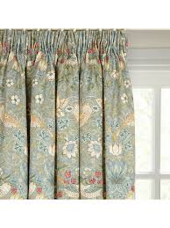  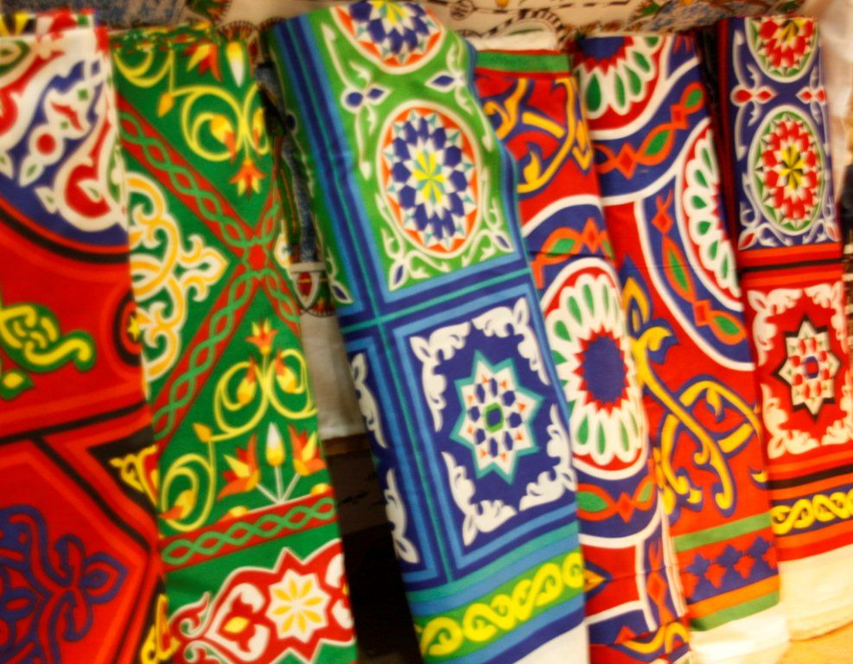 | Explore work of famous textiles artists (e.g. William Morris or inspired by Islamic art) and create own designs (tea towels, table clothes, duvet covers, cushion covers, curtains) inspired by these artists using printing or cross stitch onto different fabrics

