Goonhavern Primary School- Art
TOPIC: Vikings | YEAR: 4 | STRAND: Printing, Drawing and Artists
School Values
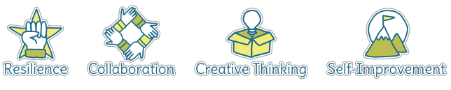
Five Ways to Wellbeing

What should I know already? | What will I know by the end of the unit?
Printing  - Use paint and printing to create repeated patterns  - Mix a variety of colours and know which primary colours make secondary colours  - Print using a variety of materials, objects and techniques including layering  - Talk about the processes used to produce a simple print  Drawing  - Use sketchbook to collect and record information, famous artwork, annotations and drawn ideas  - Start to draw for a sustained amount of time at my own level  - Line- make marks and lines with a wide range of drawing implements, including different grades of pencil  - Tone- apply different tones by drawing in a different way  - Texture- create texture with a wider range of drawing implements  - Shape- use of symmetry and shape in artwork  Artists  - Find out about the work of different artists, craft makers and designers  - Make links to own artwork  - Investigate different cultures | Drawing  - Use sketchbook to collect and record information, famous artwork, annotations and drawn ideas  - Draw for a sustained amount of time at my own level  - Line- experiment with different grades of pencil and other implements to create lines and marks  - Tone- apply different grades of pencil to achieve variation in tone  - Texture- apply simple use of pattern and texture in drawings  - Shape- begin to show awareness of shapes having a third dimension  Painting  - Experiment with different effects and textures according to what they need for the task  - Mix colours to create own desired colours, using more specific colour language e.g. tint, tone, shade, hue  - Interpret music, stories, poems and other stimuli in artwork  - Show increasing independence and creativity with the painting process  - Be able to produce a lino print  Work of other artists  - Find out about the work of different artists, craft makers and designers  - Make links to their own artwork  - Investigate different cultures  Evaluation  - Evaluate my work and that of other artists using the language of art, craft and design

Vocabulary
Andy Warhol | (1928-1987) American artist who was a leading figure in the Pop Art movement | pattern | A repeated decorative design
artist | A person who creates art as a profession or hobby | printing | A technique used to create an image using a reusable carved stamp. There are different types of printing.
blending | Mixing two or more colours to soften lines | score | Marked lines where two pieces will be joined together
blocking | Painting in simple blocks, or shapes, of colour | sculpt | To make a 3-D piece of art by casting, chiselling or constructing
clay | A stiff, sticky earth that can be moulded when wet and is then dried to make pottery | scumbling | Creating controlled scribbled marks
craft makers | People who are skilled at making things by hand | shade | A colour mixed with black to make it darker
designers | People who plan the look of something before it is made | shape | The outside line of something
details | Minor decorative features | sketch | A quick, rough drawing
evaluate | To make a judgement or have an opinion about | slip | A liquid that joins clay
hatching | An artistic technique used to create tonal or shading effects by drawing closely spaced parallel lines | stippling | Small, distinct dots of colour are applied in patterns to form an image
join | To link or connect materials | technique | A way of doing something
line | A long narrow mark or band | texture | The feel or appearance of a surface
linograph print | A type of printing where a design is etched into a reusable surface | tone | The lightness or darkness of a colour
medium | Refers to the different materials that can be used to create a piece of art | observational drawings | A visual representation of something an artist sees
mixed media | A picture created using more than one medium | pastels | Crayons made from powdered pigments

Image/diagram that helps me to articulate my knowledge/understanding | Investigate!
Andy Warhol biographical information:  https://www.tate.org.uk/art/artists/andy-warhol-2121  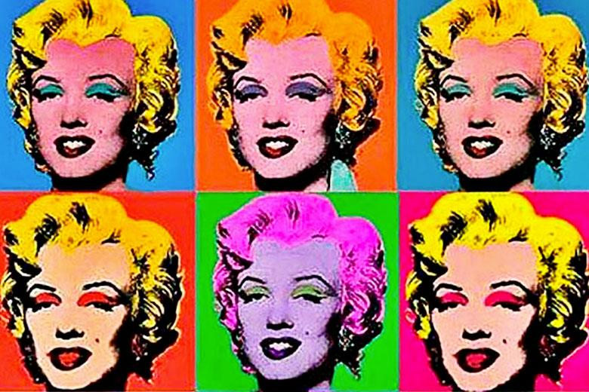  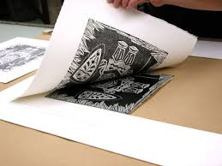  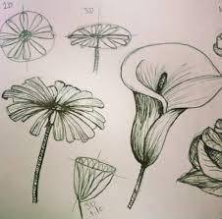 | Printing and Other Artists  - Analyse and evaluate the work of Andy Warhol with a particular focus on portraits of famous icons  - Research famous Roman figures, investigating why they were famous and how this relates to colour and style choice for a new print  - Learn new printing techniques  - Create a lino print of a key Roman figure based on research  - Examine the use of pattern in Roman designs  Drawing  - Children will learn the importance of quick, observational fieldwork sketches to then work with later on  - Observational drawings in sketchbooks based on plants

