Goonhavern Primary School- Music
TOPIC: How does music help us to understand our neighbours? | YEAR: 1 | STRAND: Introducing tempo and dynamics

What should I know already? | What will I know by the end of the unit?
I am able to sing songs and make pieces of music using a range of sounds. I can improvise on a glockenspiel or xylophone. I can recognise high and low notes. I can play and sing songs by ear. I can recognise rests and create melodies using music technology. | I can improvise using the notes F, G and A on a glockenspiel or xylophone.
 | I can recognise a steady beat, high and low, fast and slow, loud and quiet, related to the song.
 | I can sing a song in both high and low voices and talk about the difference between them.
 | I can play and perform songs using my ear and notation.
 | I can create a simple melody using up to 5 notes.
School Values
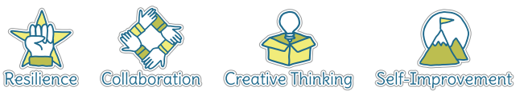
Five Ways to Wellbeing

Vocabulary
Improvise | To create and perform without preparation.
High | A note played, sung or written towards the top of a musical stave.
Low | A note played, sung or written towards the bottom of a musical stave.
Melody | A sequence of single notes that makes a musical tune.
Steady beat | A consistent pulse in the music.
Notes | A written sign to represent the pitch and duration within music.

Image/diagram that helps me to articulate my knowledge/understanding | Investigate!

