Goonhavern Primary School-Geography
TOPIC: Geography | YEAR: 3 | STRAND: What Makes A Community?

What should I know already? | What will I know by the end of the unit?
- The world’s seven continents and five oceans  - Names of some cities in the UK  - Identify weather patterns in relation to the equator and the poles  - How to use world maps, atlases and globes to identify the UK  - Know south, north, west and east | Locational Knowledge  Name and locate countries and cities of the UK.  Know there are different types of Community across the world and country.  Locate communities and have an understanding of size difference.  - The world is considered the largest community  - Communities vary in size, continent, country, county, city, town, village, street, school,clubs,church, family etc.  - Goonhavern is a village in the county of Cornwall and a community we are all part of  - Our families are our smallest community  Human and Physical geography  Human geography-types of settlement and land use, economic activity including trade links with a focus on the local community and it’s trade and economic activity  Know how a community like Goonhavern trades and how the land is used in the community and how it has changed over time and for what reasons  - Villages like Goonhavern rely on economic activity such as shops and small business to provide jobs in the community  - The area contains several small villages but there are few shops and so people have to travel to their nearest town from time to time to make purchases or the Internet.  - The majority of the population, however, is connected in one way or another with the land and consequently is reasonably self sufficient as far as the provision of fresh food is concerned.  - Apart from farming and work on the land, many of the population supplement their income from the tourist trade which is a growing industry.  Geographical skills and fieldwork  Use fieldwork to observe, measure, record and present the human and physical features in the local area using a range of methods including sketch maps, plans and graphs.  - A sketch map is a rough map drawn with basic detail  - Both physical and human features can be represented on a map
School Values
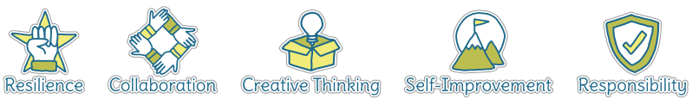
Five Ways to Wellbeing
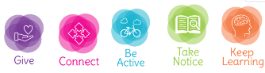

Vocabulary
Community | A group of people who share location or values.
Trade | Action of buying and selling goods and materials.
Key | Use of symbols to explain a map.
Land Use | Land use is when an area is used for a specific purpose.
Economic activity | Making, providing, purchasing and selling goods.
Village | A built-up area with a name, defined boundaries, and local government, that is larger than a village and generally smaller than a city.
Town | A built-up area with a name, defined boundaries, and local government, that is larger than a village and generally smaller than a city.
Settlement | A place, typically one which has previously been uninhabited, where people establish a community.

Image/diagram that helps me to articulate my knowledge/understanding | Investigate!
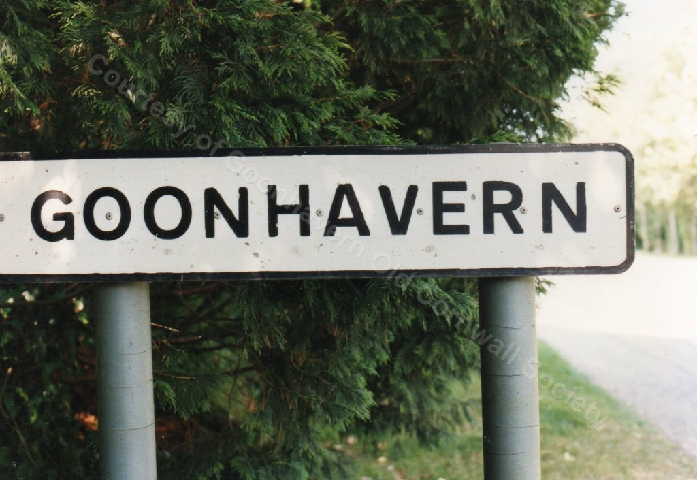  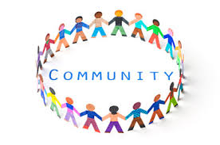 | What is a community? What communities am I part of? Who is important in a community?  Where are important places in Goonhavern?Why are they important?  How has it changed over time? How might it change in the future?  What does the village look like on a map?

