Goonhavern Primary School- Music
TOPIC: How does music tell stories about the past? | YEAR: 1 | STRAND: Adding rhythm and pitch

What should I know already? | What will I know by the end of the unit?
I am able to sing songs and make pieces of music using a range of sounds. I can improvise on a glockenspiel or xylophone. I can recognise high and low notes. | I can improvise using the notes C, D, E and F# on a glockenspiel or xylophone.
 | I can move to the beat and sing along to songs as a group.
 | I can play and perform an instrumental part by ear.
 | I can compose a simple melody using between two and five notes.
School Values
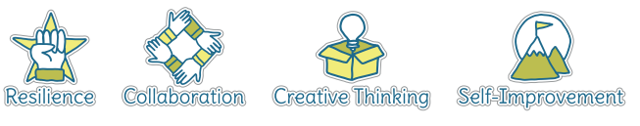
Five Ways to Wellbeing

Vocabulary
Improvise | To create and perform without preparation.
Composition | To make up a piece of music.
Quavers | A musical note worth half a beat.
Crotchets | A musical note worth one full beat.
Minims | A musical note worth two full beats.
Melody | A sequence of single notes that makes a musical tune.
Graphic Score | An image or picture with symbols to represent notes.
Notes | A written sign to represent the pitch and duration within music.
Beat | A regular, rhythmic (and sometimes strong) sound.

Image/diagram that helps me to articulate my knowledge/understanding | Investigate!
What piece can you create using the notes C, D, E and F# on a glockenspiel or xylophone?
What songs can you sing by ear? Any Christmas songs?

