Goonhavern Primary School- Music
TOPIC: How does music make a difference to us every day? | YEAR: 3 | STRAND: Learning More about Musical Styles

What should I know already? | What will I know by the end of the unit?
I am able to sing songs and make pieces of music using a range of sounds. I can improvise on a glockenspiel or xylophone. I can recognise high and low notes. I can play and sing songs by ear. I can recognise rests and create melodies using music technology. I can explain what the words ‘tempo’ and ‘dynamics’ are. I can perform my compositions to others with confidence. I can structure musical ideas so my composition has a beginning, middle and end. | I can play the notes F, G, A, Bb and C on a glockenspiel.
 | I can recognise and read simple notation.
 | I can recognise major and minor keys as well as describing the tempo and dynamics of a piece of music.
 | I can identify musical intervals and melodic steps.
 | I can perform my compositions to others.
 | I can recognise minims, crotchets and quavers.
 | I can structure musical ideas so my composition has a beginning, middle and end.
School Values
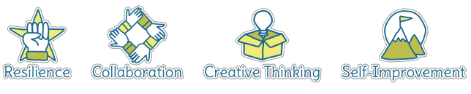
Five Ways to Wellbeing
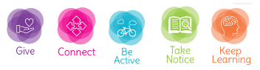

Vocabulary
Composition | To make up a piece of music.
Quavers | A musical note worth half a beat.
Crotchets | A musical note worth one full beat.
Minims | A musical note worth two full beats.
Melody | A sequence of single notes that makes a musical tune.
Tempo | How fast or slow a piece of music is.
Beat | A regular, rhythmic (and sometimes strong) sound.
Major key | A seven-note scale which often sounds happy. The most common scale in western music.
Minor key | A seven-note scale which often sounds sad or eerie.
Notation | A visual representation of music.
Musical intervals | A melody that leaps.
Musical steps | A melody that moves to the next note.

Image/diagram that helps me to articulate my knowledge/understanding | Investigate!

