Goonhavern Primary School- Geography
TOPIC: Geography | YEAR: 5 | STRAND: Biomes of the world

What should I know already? | What will I know by the end of the unit?
- The world’s seven continents and five oceans  - Names of some cities in the UK  - Identify weather patterns in relation to the equator and the poles  - How to use world maps, atlases and globes to identify the UK  - Know south, north, west and east  - Local geography from our community  - The wonders of world-where they are and how they were formed  - How to draw a sketch map and use a key  - Where food is grown and why and how it is transported  - Facts about our coastline and how we can | Locational:  What is a Biome and where are they in the world?  - The major biomes are marine, tundra, rainforest, desert and temperate  - A biome is a large naturally occurring community of flora and fauna occupying a major habitat  - These biomes support life on the planet, influence weather patterns, and help to regulate temperature.  - Tundra regions are found in the northern and southern hemispheres between the ice-covered poles and the taiga or coniferous forests. In the north, this biome stretches across northern Canada and Alaska, Siberia and northern Scandinavia, on or close to the Arctic Circle.  - The marine biome is the biggest biome in the world! It covers about 70% of the earth. It includes five main oceans: the Pacific, Atlantic, Indian, Arctic, and Southern, as well as many smaller Gulfs and Bays. Marine regions are usually very salty!  - The marine biome is integral to life on earth and provides lots of oxygen. Pollution, increase in water temperature and over fishing means many marine species are in danger and need to be protected. Raising money for wildlife trusts can help with this.  - The largest rainforests are in the Amazon River Basin (South America), the Congo River Basin (western Africa), and throughout much of southeast Asia.  - The worlds rainforests are being cut down due to human demand, this has a devastating impact on climate change and wild animal habitat loss. This is turn impacts human disease. Reducing/ looking after what we buy and making sustainable choices can help with this.  - The hot deserts of the world are located between 15° and 30° north or south of the equator, where the air is subsiding or sinking air  - Temperate deciduous forests can be found in the eastern part of the United States and Canada, most of Europe and parts of China and Japan. The temperate deciduous forest is a biome that is always changing.  Physical Geography:  What animals are found in the biomes?  - The marine biome has the most biodiversity of all the biomes. Many of the animals, such as fish, have gills that allow them to breathe the water. Other animals are mammals that need to come to surface to breathe, but spend much of their lives in the water. Another type of marine animal is the mollusk which has a soft body and no backbone.  - Animals found in the tundra include the musk ox, the Arctic hare, the polar bear, the Arctic fox, the caribou, and the snowy owl. Many animals that live in the tundra, like the caribou and the semipalmated plover, migrate to warmer climates during the winter.  - Foxes, spiders, antelopes, elephants and lions are common desert species  - There are a wide variety of animals that live here including black bears, mountain lions, deer, fox, squirrels, skunks, rabbits, porcupines, timber wolves, and a number of birds.  - Rainforests are tremendously rich in animal life. Rainforests are populated with insects (like butterflies and beetles), arachnids (like spiders and ticks), worms, reptiles (like snakes and lizards), amphibians (like frogs and toads), birds (like parrots and toucans) and mammals (like sloths and jaguars).  What is the climate in each biome?  - Some biomes are characterized by extremely cold temperatures and treeless, frozen landscapes.  - Others are characterized by dense vegetation, seasonally warm temperatures, and abundant rainfall.  - The environment is pretty wet in tropical rainforests, maintaining a high humidity of 77% to 88% year-round. The yearly rainfall ranges from 80 to 400 inches  - The tundra is coldest of all the biomes with an annual average temperature less than 5°C, and precipitation  - Most deserts are warmer during the day than they are at night, and the difference in temperature is quite drastic. The average daytime temperature is 100°F, while at night the average temperature is 25°F. This large temperature difference is due to low amount of moisture in the desert air  - The climate of the marine biome is mostly varied. Since it is the largest biome in the world, the climate varies from -40 degrees fahrenheit to over 100 degrees.  - The average temperature in temperate deciduous forests is 50°F (10°C). Summers are mild, and average about 70°F (21°C), while winter temperatures are often well below freezing.  What plants are found in each biome?  - Temperate deciduous forests have a great variety of plant species. Most have three levels of plants. Lichen, moss, ferns, wildflowers and other small plants can be found on the forest floor. Shrubs fill in the middle level and hardwood trees like maple, oak, birch, magnolia, sweet gum and beech make up the third level.  - Desert plants can be classified into three main categories: Cacti and Succulents, Wildflowers, and Trees, Shrubs, and Grasses  - Some plants that grow in the tundra include short shrubs, sedges, grasses, flowers, birch trees and willow trees.  - Over 1 million species of plants and animals have been discovered in the oceans, and scientists say there may be as many as 9 million species we haven't found yet.  - Ferns, lichens, mosses, orchids. The tropical rainforest is also home to pitcher plants.  Human Geography:  How is the land used by humans?  - Human activity and development in the tropical rainforest has lead to massive amounts of forest land being converted into other human uses such as mining or agriculture  - Many of the permanent residents of tundra regions are indigenous people, such as Alaska's Aleut and Inuit tribes, and rely on subsistence hunting and gathering in order to survive
School Values
Five Ways to Wellbeing

Vocabulary
biome | A large naturally occurring community of flora and fauna occupying a major habitat
tundra | A vast, flat, treeless Arctic region of Europe, Asia, and North America in which the subsoil is permanently frozen.
Marine | Relating to or found in the sea.
Temperate | Relating to or denoting a region or climate characterized by mild temperatures.
Rainforest | A luxuriant, dense forest rich in biodiversity, found typically in tropical areas with consistently heavy rainfall.
Desert | A dry, barren, treeless region, usually sandy.
Abundant | Plentiful.
Species | A group of living organisms consisting of similar individuals.
Humidity | A quantity representing the amount of water vapour in the atmosphere.
Deciduous | (Of a tree or shrub) shedding its leaves annually.
Precipitation | Rain, snow, sleet, or hail that falls to or condenses on the ground.

Image/diagram that helps me to articulate my knowledge/understanding | Investigate!
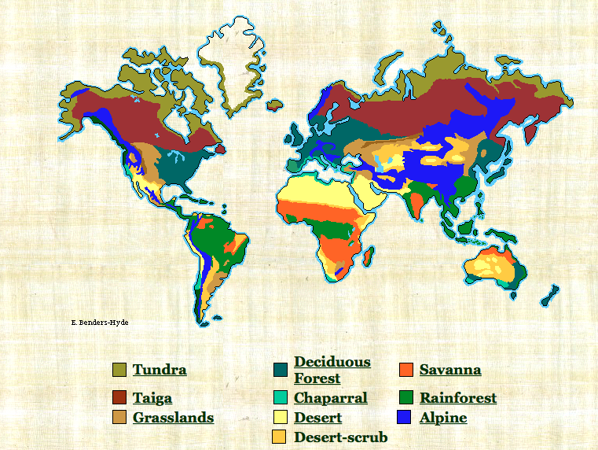 | What can we discover in the biomes? How do animals survive in each biome? How does human activity affect the biomes? Can we help or hinder natural life in the biomes?  Compare Biomes to our local environment.  Connect with experts in this field. .

