Goonhavern Primary School- PE
TOPIC: PE | YEAR: 3 | STRAND: Gymnastics

What should I know already? | What will I know by the end of the unit?
How to create a short sequence of movements with a beginning, middle and end  Create more challenging shapes and balances using different body parts  How to safely perform these shapes/balances on apparatus  How to safely and creatively travel low and high, changing pace/direction and across apparatus  How to smoothly transition from a movement into a balance  To know and create the body shapes: Star, Tuck, Pike, Arch and Dish  Know different types of rolling:  Pencil (sausage), Hedgehog (forward), Rocking (onto back) Rocking to stand with help  How to safely perform straight jumps off apparatus and land with a good technique | To develop my gymnastic basic floor shapes such as crab & bridge
 | To develop my gymnastic floor movement side roll to knee, teddy bear roll, forward roll and diving forward roll
 | To know gymnastic floor shapes such as V-Sit, shoulder stand, planche and frog balance
 | To develop my gymnastic floor shapes when working with others front & back support pair/trio balances
 | To link Floor Shapes and Floor Movement To link skills together with flow and control
 | To develop my climbing and Apparatus Skills Climbing Up, Climbing Down, Traversing, 3 Point Holds and Safety Awareness
 | To develop my movement and balance on the Bench V-Sit and Jumping on the Bench
 | To develop my mounting, jumping and landing Vault Mount the Vault, Straight, Star & Tuck Jump Dismount
School Values
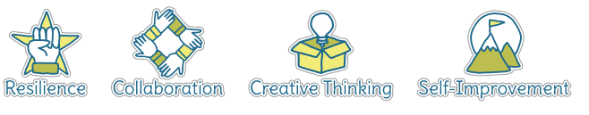
Five Ways to Wellbeing
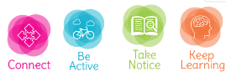

Vocabulary
Floor Shapes | Shapes you create on the mat
Crab | Face up arching back up
Bridge | Face down arching back up
Teddy Bear Roll | Roll to the side
Forward Roll | Head first roll
V-sit | Straight legs and back creating a V shape
Shoulder Stand | Legs shoulder width apart
Planche | The body is held parallel to the ground, while being supported above the floor by straight arms.
Frog Balance | Crouching holding weight with only hands
Traversing | Going backwards
Vault | Gymnastic apparatus
Mount | Climb onto
Dismount | Climb off

Image/diagram that helps me to articulate my knowledge/understanding | Investigate!
See Links ----> | Create short sequences as a class, in groups and pairs  Give opportunity to watch others, copy routines and comment on techniques whilst giving peer feedback  Build up from floor shapes to creating these on apparatus building up confidence to get higher  Games to play:  https://www.sportaus.gov.au/__data/assets/pdf_file/0012/704001/Team-alphabet.pdf  https://www.sportaus.gov.au/__data/assets/pdf_file/0006/703986/Shapes-in-space.pdf  https://www.sportaus.gov.au/__data/assets/pdf_file/0006/703986/Shapes-in-space.pdf

