Goonhavern Primary School- SPANISH
TOPIC: At the Market- Al mercado | YEAR: 5 | STRAND: Languages

What should I know already? | What will I know by the end of the unit?
Y3 T2:  - Be able to say in Spanish what we are good at  - To know Spanish numbers to 10.  - Can understand and respond to a range of familiar spoken words and short phrases.  - Can join in the re-telling/playing of a familiar story, song, rhyme or poem using gestures or by saying key words and phrases  - Can recognise key sounds and words that rhyme.  - Can match key sounds and words that rhyme.  - Can rehearse and perform short role plays drawing on one topic, with several exchanges and secure pronunciation.  - Is beginning to understand how to form questions/answers independently.  - Can use simple pre-learned words and phrases for routine situations and interaction.  - Can produce short pre-prepared phrases on a familiar topic, with secure pronunciation.  - Can match sound to print, by reading aloud familiar words and phrases.  - Can read and understand a range of familiar written phrases.  - Can identify the overall type of text from its layout, contextual cues and a few familiar words.  - Can use a word list to check the spelling of a word.  - Can use a dictionary or online resource to check the spelling of a word.  - Can write simple words and several short phrases from memory with understandable spelling.  - Can substitute one element in a simple phrase or sentence to vary the meaning. E.g the colour, adjective or noun.  - Can use indefinite articles in singular and plural and definite articles in both singular and plural. Can use a variety of plural nouns, including some irregular ones.  - Can use adjectives (agreement and position) with more confidence. Can use ‘tiene’ (3rd person tener) and está (3rd person estar).  - Can use connectives ‘and’(y), ‘but’ (pero), ‘also’ (además) | To ask for a product at a market
 | To ask questions about that product
 | To be able to ask for a quantity e.g. kilo
 | To know the names of different fruits and vegetables in Spanish
 | Pupils are to understand and communicate ideas, facts and feelings in speech and writing, focussed on familiar and routine matters, using the knowledge of phonology, grammatical structures and vocabulary.
School Values
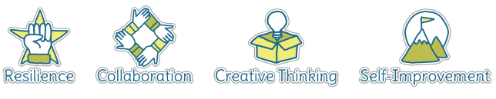
Five Ways to Wellbeing

Vocabulary
¿Tienes…? | Do you have…? | El mercado | The market | El ajo | garlic
¿Cuánto es…? | How much is…? | Las frutas | Fruit | Las zanahorias | carrots
¿Cuánto pesa/n? | How heavy is that? | tomates | tomato
Quiero… | I would like… | naranjas | orange
Tengo | I have | peras | pear
No tengo | I have not | ciruelas
Pesa/ pesan | It weighs/ they weigh… | fresas | strawberry
Un kilo | A kilo | manzanas | apple
Un medio kilo | Half a kilo | El plátano | banana
Dos euros | Two euros | El melocotón | peach
Por favor | please | Las verduras | vegetables
Gracias | Thank you | La cebolla | onion
 |  | Las patatas | potato

Image/diagram that helps me to articulate my knowledge/understanding | Investigate!
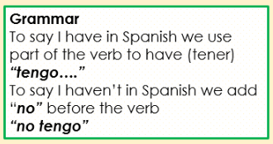  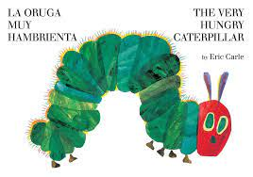 | VIDEO LINK: https://youtu.be/3m8aqvYWuBU  The Very Hungry Caterpillar (La pequena oruga glotona)  VIDEO LINK: https://youtu.be/0Xji5krOhTI

