Goonhavern Primary School- Design Technology
TOPIC: DT | YEAR: 4 | STRAND: Electricity

What should I know already? | What will I know by the end of the unit?
I know how to make a simple electric circuit using batteries, light bulbs, motors, switches and fans | How to construct circuits, incorporating a battery or power supply and a range of switches, to make electrical  devices work
 | How to create a design using represent series circuits by drawings and conventional symbols, and how to construct series circuits on the basis of drawings and diagrams using conventional symbols
select tools, techniques and materials for making their product from a range suggested by the teacher
• suggest alternative ways of making their product, if first attempts fail
• explore the sensory qualities of materials and how to use materials and processes
• measure, cut and shape a range of materials
School Values
Five Ways to Wellbeing

Vocabulary
circuit | An electrical circuit is a path in which electrons from a voltage or current source flow.
Battery | a container consisting of one or more cells, in which chemical energy is converted into electricity and used as a source of power.
Energy | power derived from the utilization of physical or chemical resources, especially to provide light and heat or to work machines.
Electric | worked by, charged with, or producing electricity.
Fan | an apparatus with rotating blades that creates a current of air
Aerodynamic | of or having a shape which reduces the drag from air moving past.
pulley | a wheel with a grooved rim around which a cord passes, which acts to change the direction of a force applied to the cord and is used to raise heavy weights.
Axles | a rod or spindle (either fixed or rotating) passing through the centre of a wheel or group of wheels

Image/diagram that helps me to articulate my knowledge/understanding | Investigate!
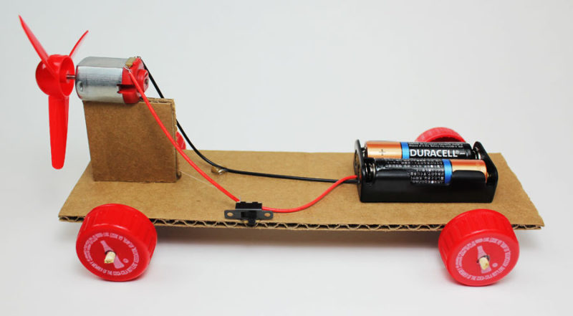 | Link to science/electricity and make fan powered cars. Test cars for speed, agility and aerodynamics. Which materials work best? Where is the fan best placed?

